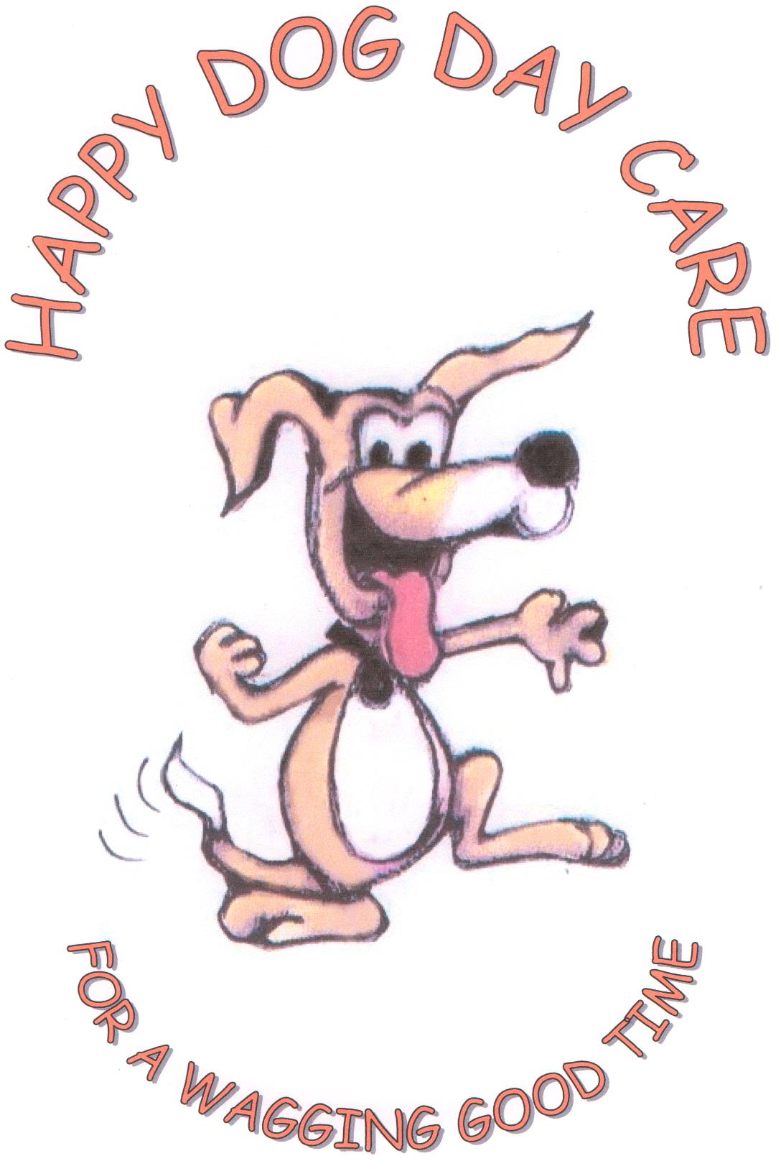 Happy Dog Day Care Owner & Pet Information Form

*Note: Please make sure this form is signed and dated so we can continue with the booking.

Owner Information (Please Print)

Name______________________________________________________

Address ____________________________________________________

Suburb ___________________ State ____________ Postcode ________

Home Phone_______________ Mobile ___________Work ___________

Email Address_______________________________________________

Emergency Contact Name _____________________________________

Home Phone_______________ Mobile____________ Work _________

Pet Information

- Name_______________ Breed______________ Male / Female

Age _______ Colour __________ Desexed?: Yes / No

Date of Birth___

- Name_______________ Breed______________ Male / Female

Age __________ Colour Desexed? : Yes / No

Date of Birth___________

Veterinary Clinic

Vet’s name __________________________________________________

Practice _________________________________Telephone__________

Address ____________________________________________________

Suburb ______________________ State ________ Postcode ________

PET PERSONALITY PROFILE

Has your dog/s attended day-care or sleepovers before? Yes/No

If yes, where? ________________________________________________

Do you have any other pets? __________ If yes, how do they get

along?_____________________________________________________

Health and Grooming

When was your dog/s last vaccination ?__________ *note all dogs must have a C5 vaccination*

Is your dog on a flea treatment program? _____ If so, which

one?_______________________________________________________

Is your dog on heartworm prevention?________ If so, which

one?_______________________________________________________

Does your dog/s have any medical conditions we need to know about? ____
If so, please specify the condition and if your dog is on medication, needs to be restricted from some activities____________________________________________________

Does your dog/s have any allergies or food restrictions?

Behaviour

Has your dog/s ever bitten a person or another dog?_________ What were

the circumstances?____________________________________________

Does your dog/s growl when eating a bone or food and you get too close or one of your other pets gets too close?______________________________________________________

Has your dog/s ever snapped or growled at anyone taking food or toys away? Or has your dog snapped or growled at other dogs taking food or toys away? ___________________________________________________________

Has your dog/s ever snapped at a person or another dog or pet?__________

If so, what were the circumstances?______________________________

Is your dog/s overly nervous or frightened about things eg: Vacuum,

Thunder, Fireworks, Umbrellas, Loud noises?______________________
How does your dog/s react to other dogs approaching while they are out on their walks with you - Do they growl, bark, wag their tail.
Please specify if this happens when:

- On lead________________________________________________

- Off lead _______________________________________________

Has your dog/s ever jumped or climbed over a fence?______ Height of the

fence?______________________________________________________

Does your dog/s have any of these problems ( Please tick any that apply)
- Mouthing ( chews on your hand, clothing)
- Housetrainig
- Excessive barking
- Chewing/Destructiveness
- Separation Anxiety (crying when left alone, barking)

How often and where does your dog/s socialise with other

dogs?______________________________________________________

Are you able to remove things from your dog’s mouth? _______________

Is your dog/s fearful or aggressive around other dogs small or

Large? ______________________________________________________

How does your dog/s react to puppies? _____________________________

What do you do with your dog/s when you are not at

home?_____________________________________________________

What obedience training has your dog/s had? ______ If so, what commands do they understand? ___________________________________________________________

Is there anything else we should know that was not covered on this form? If so, any extra information about your dog could be helpful in our care of your dog._______________________________________________________

How does your dog react when strangers enter your property?
___________________________________________________________

Doggie Day Care Information

Do you give permission for your dog/s to be walked outside of the day care centre on a lead? Yes/No

Do you give permission for your dog/s to be let off the lead in a park that allows off the lead dogs? Yes/ No (please read note below before ticking)

Note* Before ticking yes to off the leash parks, please advise us if your dog/s are used to doing this and that they return when called, allowing this will be at your own risk., The carer will to the best of their ability assure the safety of your dog during this activity.

Do you give permission for your dog/s to be given treats during the stay with us at doggie day care? Yes/No

Does your dog/s require meals during the day while at dog day care? Yes/No
- (Please note all food to be supplied by the owner to avoid any tummy upsets)

Sleepover & Home feeding Information

Do you give permission for the carer to walk your dog on a lead while you are away? Yes/No

Do you give permission for a carer to enter your premises for the purpose of taking care of your pets?

Yes/No

Do we have your permission to transport your pet in our car as a part of our family’s activities? Yes/No

Market Information

How did you hear about us? --------------------------------------------------

Do we have your permission to use photographs of your pet for newspaper, website, flyers and
brochures? Yes/No

Terms and Conditions

- Bookings essential
- Puppies welcome from 10 weeks must have 1st Vaccination
- Up to 6months can be entire
- Over 6 months must be spayed
- All dogs must wear collar and ID tag
- All dogs must arrive and leave on a leash
- Dogs must be friendly with people, other dogs, must not be territorial with food, toys and space
- Dogs must be friendly when entering their property( home feeding services)
- All dogs must be vaccinated and wormed
- If dogs require medication, owner must supply with instructions
- Sick Dogs - dogs cannot attend if unwell with contagious conditions eg: kennel cough
- Clients must advise on any change of contact details
- No refund on any circumstances once payment is made.
- Late charges of $10 per 10 mins or part thereof after 6.30pm( Daycare only)

Reservations:
Reserve your dog’s visit as far in advance as possible. Space at “Happy Dog Day Care & Sleepovers” is on a first-come, first-served basis so it pays to plan early
Where a permanent booking for Doggy-Day care is made unused days will still be charged.

“Happy Dog Day Care” & Sleepovers Agreement

I, ………………………………………………………………………………………, hereby certify that my dog(s):
…………………………………………………………………………………… is/are in good health and have not been ill with any communicable diseases in the last 30 days
I further certify that my dog(s) have not harmed or shown aggressive or threatening behaviour towards any person or any other doggy. I have read and
understand the following:
1. I understand that I am solely responsible for any harm caused by my dog(s) while my dog(s) is/are attending “Happy Dog Day Care” & Sleepovers

2. I further understand and agree that in admitting my dog(s) to “Happy Dog Day Care” & Sleepovers , the staff have relied on
my representation that my dog(s) is/are in good health and have not harmed or shown aggressive or threatening behaviour towards any person or any other doggy.

3. I further understand and agree that “Happy Dog Day Care” & Sleepovers and their staff and volunteers will not be liable for any
problems which develop, provided reasonable care and precautions are followed, and I hereby release them of any liability of any kind whatsoever arising from my dog(s) attendance and
participation at “ Happy Dog Day Care” & Sleepovers.

4. I further understand and agree that any problems which develop with my dog(s) will be treated as deemed best by the staff and volunteers of “Happy Dog Day Care” & Sleepovers at their sole discretion, and that I assume full financial responsibility for any and all expenses involved.

5. I further understand that when using the home feeding or walking service I have given permission for a carer to enter my property to perform the service agreed upon by Happy Dog Day Care and myself, I also certify that all the information given about my dog/s temperament is true to the best of my knowledge, to insure the safety of the carer.

6. I understand that while at day care my dog/s will be in the company of other dogs.

I certify that I have read and understood the policies of “Happy Dog Day Care” & Sleepovers as set forth and that I have read and
understand the conditions, and statements of this agreement, including the following:

Fees: Payable in advance for both daycare & sleepovers.
Accounts in arrears for more than 30 days will be forwarded to Debt Recovery and legal proceedings will be instituted without further notice and any legal costs shall be incurred by the account owner.
We accept cash, cheque and direct deposit – receipts will be offered and issued on pickup of your dog.

Late pick-ups will be charged at $10.00 every ten minutes past 6:30 pm on weekdays and $15 on Saturday rate after 2pm.
Late pickup (prior arrangements required) - $10.00
Sleepovers must be booked in advance – 25% non refundable deposit on booking, balance to be paid to “Happy Dog Day Care” one week in advance of drop off.
Home feeding and other services – 25% non refundable deposit on booking, balance to be paid one week in advance of service.

Other Fees:
Vet transportation fee - $10.00
20% surcharge for public holidays (Sleepovers & Home services only)
$10 per dog interview fee

Cancellations:
Late cancellations and no-shows will be charged full fees. Concessions for medical reasons will be considered on a case-by- case basis by “Happy Dog Day Care” & Sleepovers staff.

I certify that I have answered the above questions fully and to the best of my ability.

By signing this form, you accept the agreement, terms and conditions of Happy Dog Day Care & Sleepovers”

Owner’s Signature:
……………………………………………………………………………

Date: …………………….

Before me………………………………………………….. (to be signed by a witness)

Signature of witness……………………………………………………..

Don’t leave your doggie home alone! Send them to Doggie Day Care.
Your doggie’s day will be filled with individual love and attention.

Refer us to family and friends and receive 5% off your next booking.

Call us now or visit our website .
Happy Dog Day Care & Sleepovers
57 Cassowary Street
Doncaster East
Victoria 3109
Melway: 48 A3

Monday to Friday 7am to 6.30pm

For further enquiries call: Georgina: 0425790501
Email: georgina@happydogdaycare.com.au

Website: www.happydogdaycare.com.au

ABN 15 773 211 928

